# Safety and Security

Safety and Security 1

Windows Defender 1

Windows SmartScreen 1

#### Timing for This Module

|  |  |
| --- | --- |
| Delivery Length: 15 Minutes | Additional Lab Time: 10 Minutes |

#### Overview

This module briefly discusses the changes introduced for Windows SmartScreen and Windows Defender in Windows 8.

## Windows Defender

In Windows® 8, Windows Defender provides real-time protection from all known forms of malware, including worms, viruses, Trojans and more, by intercepting and inspecting data and activity on Windows that matches known signatures. The engine and signatures used by Windows Defender to accomplish this are the same used by Microsoft Security Essentials and Forefront Endpoint Protection.

Windows Defender will automatically scan your PC for malicious software (including viruses) at the time defined for Automatic Maintenance in Action Center. The default is 3 A.M.

**Note:** Despite the fact that Microsoft® is now including an antivirus solution with Windows, we should never recommend that customers use Windows Defender instead of their thirdparty antivirus solution. Microsoft believes that the greatest security for our customers comes from having a healthy security community. Our customers benefit from the availability of alternative security software. However, we do recommend that customers use security software that is certified for their version of Windows. While there are many security software solution certified for Windows 7, it is not yet the case for Windows 8 since it is only just now being revealed to the public.

## Windows SmartScreen

The Windows SmartScreen® feature from Microsoft Windows Internet Explorer® has now been integrated into the entire operating system. Windows SmartScreen prevent Windows from loading binaries that are known to be malicious. Similar to SmartScreen in Internet Explorer, Windows SmartScreen will check any app downloaded from the Internet against a reputation service hosted by Microsoft. This means that programs copied from the network or downloaded with third-party browsers will also be scanned by the Windows SmartScreen service.

If SmartScreen detects an app that is either known to cause an issue or is unrecognized, it will prevent launching the installer for the app by default, as shown below. Clicking the **More info** button will display more information about the app and provide you with a **Run anyway** button.

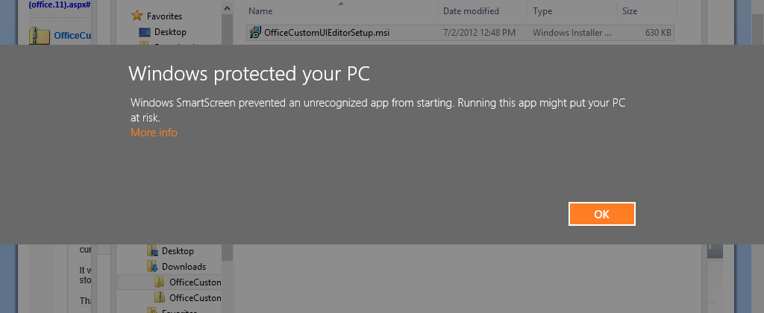

Figure : Windows SmartScreen

#### Try This: Windows SmartScreen

* Download and attempt to install the Office custom UI editor.
* Use the **Run anyway** button to proceed with the installation after it has been blocked.